Here are some ideas to display how many tickets are sold using colors:
*showing the time and event date in a different color
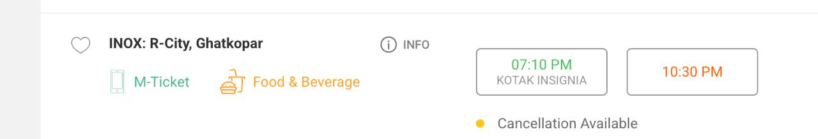
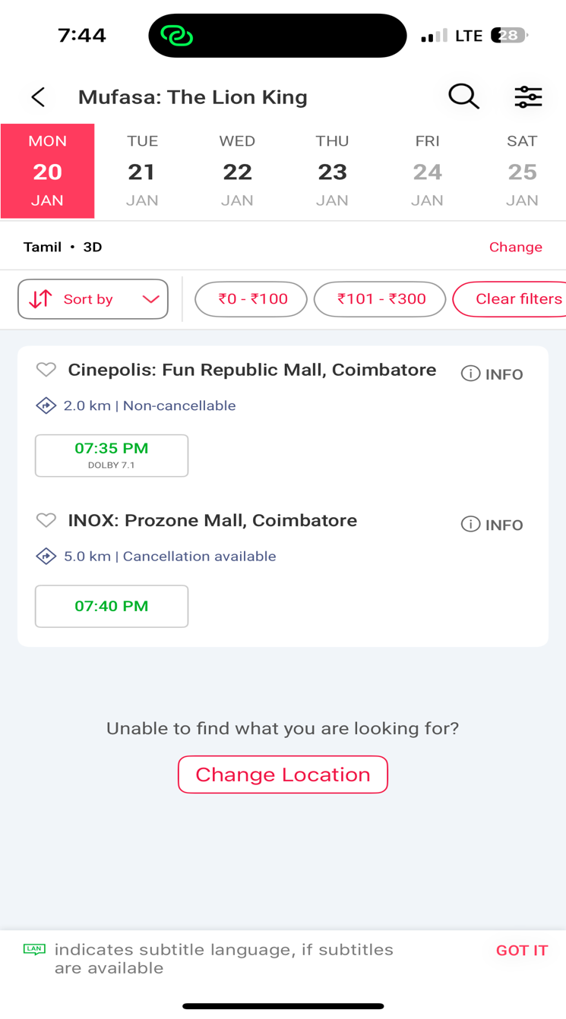
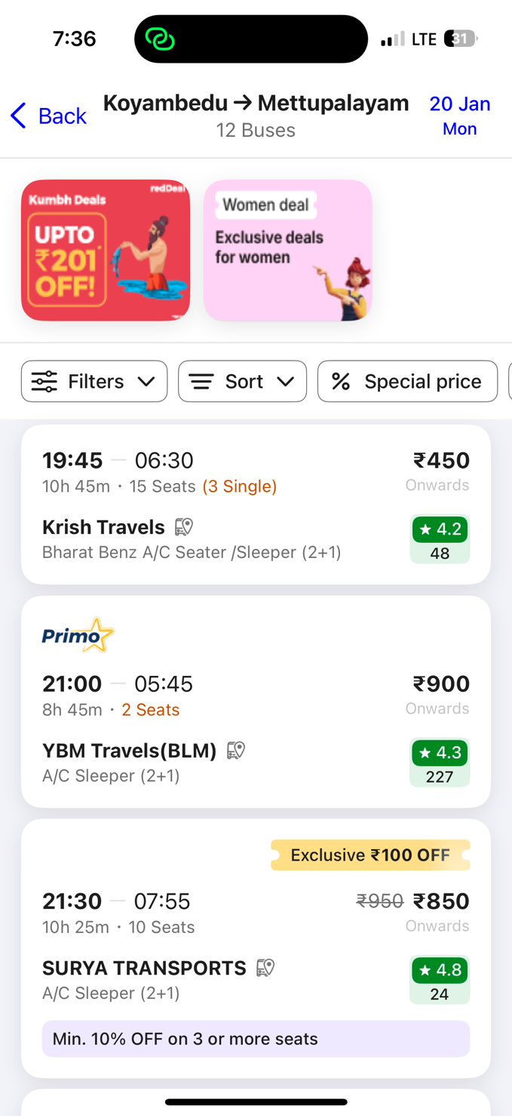
another idea is to add a box like the above box to show the availability
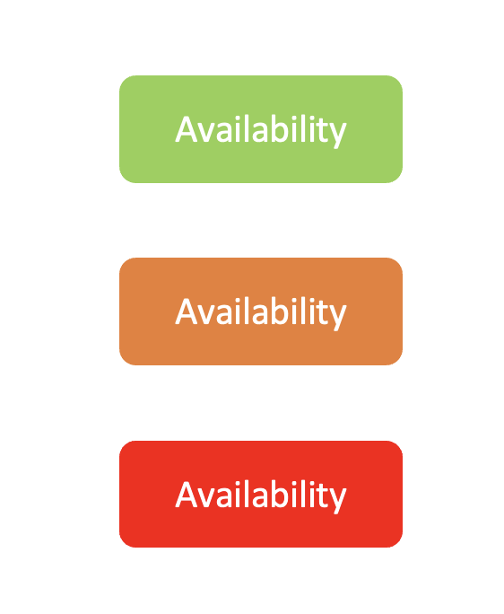
we can add a box in the card to show the availability

For the background color :


